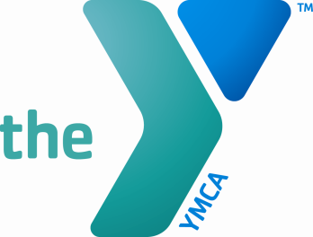

Greensburg YMCA Job Description

Job Title: Child Care Aide Job Code:
Reports to: Head Counselor, Assistant Child Care Director Revision Date: May 2013 _______________________________________________________________________
Position Summary:

The Counselor will be responsible for assisting with the daily activity plans. The Counselor will also provide an environment that is structured, inviting and fun that foster children’s social, emotional, spiritual, and mental growth.

Essential Functions:
- Planning specific camp activities on a daily basis.
- Carrying out the planned daily activities.
- Attending pre-camp and other pertinent training.
- Documenting incidents, accidents, and behavior issues observed of children at camp, and submitting those reports to the SACC Director in a timely manner.
- Having Rainy Day back up plans available for any given time.
- Report any suspected child abuse to the Department Head.
- Other duties may be assigned.

YMCA Competencies (Team Leader)
Mission and Community Oriented: Models and teaches YMCA values. Champions inclusion activities, strategies and initiatives. Ensures high-level services that differentiate the YMCA from other providers. Provides volunteers with orientation, training, development and recognition.
People Oriented: Empathetically listens and communicates for understanding when negotiating and dealing with conflict. Builds relationships to create small communities. Effectively tailors communications to the appropriate audience. Provides staff with feedback, coaching, guidance and support.
Results Oriented: Holds staff accountable for high-quality results using a formal process to measure progress. Conducts prototypes to support the launching of programs and activities. Provides others with frameworks for making decisions. Develops plans and manages best practices through engagement of team. Cultivates relationships to support fundraising. Effectively creates and manages budgets.
Personal Development Oriented: Utilizes non-threatening methods to address sensitive issues and inappropriate behavior or performance. Shares new insights. Facilitates change; models adaptability and an awareness of the impact of change.

Qualifications:
- A high school diploma or a general education development certificate and 2 years experience with children.
- Two or more year’s related experience preferred.
- At least 18 years of age, Criminal, Child Abuse and FBI clearances, pre-employment physical/TB test and an onsite drug test.
- Must complete all YMCA training certifications.
- Two letters of recommendation on file.

Physical Demands: The employee is occasionally required to reach with hands and arms and use legs to lift/move up to 25 lbs. occasionally.

Certificates, Licenses, Registrations: Must possess current Pediatric CPR, First Aid, AED, Child Abuse Prevention and Common Illness certification.

This position description is not a contract. The Greensburg YMCA reserves the right to change this position description as necessary. I have read and understand the position description, expected work schedule, and rate of compensation, and I accept this position.

EMPLOYEE SIGNATURE: _________________________________________ DATE: __________

SUPERVISOR SIGNATURE: _______________________________________ DATE: __________

HUMAN RESOURCES SIGNATURE: ________________________________ DATE: __________

