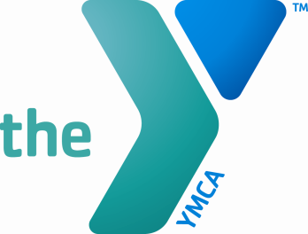

Greensburg YMCA Job Description

Job Title: Lifestyle Coach – YMCA’s Diabetes Prevention Program Job Code:
Reports to: Regional Diabetes Prevention Program Coordinator Revision Date: 8/21/14 ________________________________________________________________________
Position Summary:
The Greensburg YMCA is seeking a Lifestyle Coach who will serve as a facilitator of the YMCA’s Diabetes Prevention Program by implementing the standard curriculum in an effective, compelling way and supporting and guiding participants in the year-long program.

Essential Functions:
Under the direction of the Regional Diabetes Prevention Program Coordinator, the Lifestyle Coaches are responsible for facilitating Diabetes Prevention Program sessions and recording participant data. The year-long program consists of 16 one-hour weekly sessions, followed by eight one-hour monthly sessions. Coaches are responsible for recording weekly participant data that includes attendance, weight, physical activity and food tracker maintenance.

Class locations, days and times will be determined based on participant demand. Participants are 18 years of age or older and have prediabetes.

Education/Experience Requirements:

Successful candidates will be required to:
- Attend and pass a two-day, in-person training ($8/hour-training rate only)
  - Training to be held September 8th and 9th, overnight travel is required
- Attend a two-hour, web-based, MyNetico software training
- Attend a 30-minute, web-based HIPAA training
- Maintain at least one program cohort per year.

Qualifications:
- High school diploma/GED
- Some knowledge of basic health, nutrition, and fitness
- Strong communication skills
- The ability to build strong relationships with individuals and build community within a group
- Empathy for health seekers- the ability to create a motivating, friendly, non-competitive environment
- Flexible to work with a wide variety of people and to make learning a shared responsibility for the group
- Detail-oriented, Data and Computer savvy
- Understanding of behavior change
- Active listening or Listen First and Motivational Interviewing training preferred
- Prepared, on-time, professional- (reviews participant’s data, lesson plan, content for class, reminder calls)

NON EXEMPT HOURLY RATE: $12.50/hour- Based on running one session per week for 16 weeks, followed by 3 hours per month for 8 months. Opportunities will be on-going. EEO

SEND RESUMES TO: jpost@ligonierymca.org

This position description is not a contract. The Greensburg YMCA reserves the right to change this position description as necessary. I have read and understand the position description, expected work schedule, and rate of compensation, and I accept this position.

EMPLOYEE SIGNATURE: _________________________________________ DATE: __________

SUPERVISOR SIGNATURE: _______________________________________ DATE: __________

HUMAN RESOURCES SIGNATURE: ________________________________ DATE: __________

