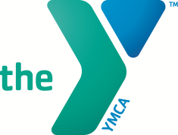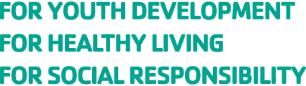

Dear Parent(s)/Guardian(s) of Greensburg YMCA Gymnastics Lessons;

This letter serves many purposes, but most importantly I would like to thank you for enrolling your child in our Greensburg YMCA Youth Gymnastic Lessons. Our goal at the Greensburg YMCA is to make a difference in every child that comes through our gymnastics program by providing a quality program that builds strength, endurance, friendships and has a lasting, enjoyable memory. The other purpose of this letter is to inform you of some of our policies related to this program which are explained below.

Parent(s)/Guardian(s) Responsibilities:
We encourage parents/guardians to stay and observe lessons or if you leave premises please inform the instructor. You must be present to sign your child in and out of lessons each week. If someone other than you will be picking up your child, the instructor must be notified via permission note. Please note: NO FOOD OR DRINK PERMITTED IN THE GYM AREA – WATER ONLY. Sports drinks are full of sugar we ask you provide water only.

Cancellation Policy:
All Gymnastic Lessons will occur as planned. In the event of inclement weather please contact the YMCA at
(724)834-0150 or follow us on face book.

Make-ups will allotted for all missed classes due to the weather and will be rescheduled through your instructor.

Refund Policy:
All refunds will be charged a $15 processing fee. Participants are eligible for a 100% refund (minus the processing fee) if a request for a refund prior to the start of class and a 75% refund will be available if the request is done after the first class or first week of program. Credits only will be offered after the second class or second week.

Communication Policy:
Our communication policy is one that emphasizes the chain of command. If you have questions regarding your child’s participation, improvement, etc. please speak with your child’s instructor or/and Jennifer Jubec Gymnastic Coordinator. However, all other questions should be directed to Drake D’Angelo Senior Program Director, email is the best means of communication.

Volunteers:
Please see Jennifer Jubec if you are interested in volunteering.

Our goal is to always communicate to our participants and members well in advance of any changes to our programs.

Again, thank you for enrolling your child in our Gymnastics Lessons program. If you have any questions or concerns please feel free to contact me.

Testimonials and Impact
The Greensburg YMCA strives to positively impact our entire community. Please do note that we offer financial assistance for individuals in need which is available through donations secured through our Strong Kids Campaign. If our YMCA has impacted you and you wish to tell us your story we would greatly appreciate the opportunity to talk with you. If you know of others that could use our facility or programs but may not have the ability to pay; please let them know of our financial assistance opportunities as we will NEVER turn anyone away based on their inability to pay.

Sincerely,

Drake D’Angelo
Senior Program Director
Greensburg YMCA
101 S. Maple Ave.
Greensburg, Pa. 15601
d.dangelo@gbgymca.org
724.834.0150 x131

